PHASE 5
Deployment & Final Validation

1. Objective
Deploy the completed application configuration to a target ServiceNow environment using a controlled Update Set process.

2. Deployment Preparation
- Open the HR Onboarding Application update set.
- Verify that all required configuration records are captured.
- Review the update set contents before completion.
- Run Update Set Preview in the target instance.
- Review and resolve preview conflicts/errors.
- Set the update set to Complete after successful validation.

3. Expected Update Set Contents
- Project Application.
- Laptop Request Form table and fields.
- Record Producer and catalog configuration.
- Business Rule.
- Roles, Groups and ACLs.
- Flow Designer approval workflow.
- Email notifications.

4. Update Set Preview
Preview the update set in the target instance and resolve any conflicts before commitment. The goal is to ensure the configuration can be safely applied without overwriting unintended changes.
Update Set Preview and resolved conflicts.
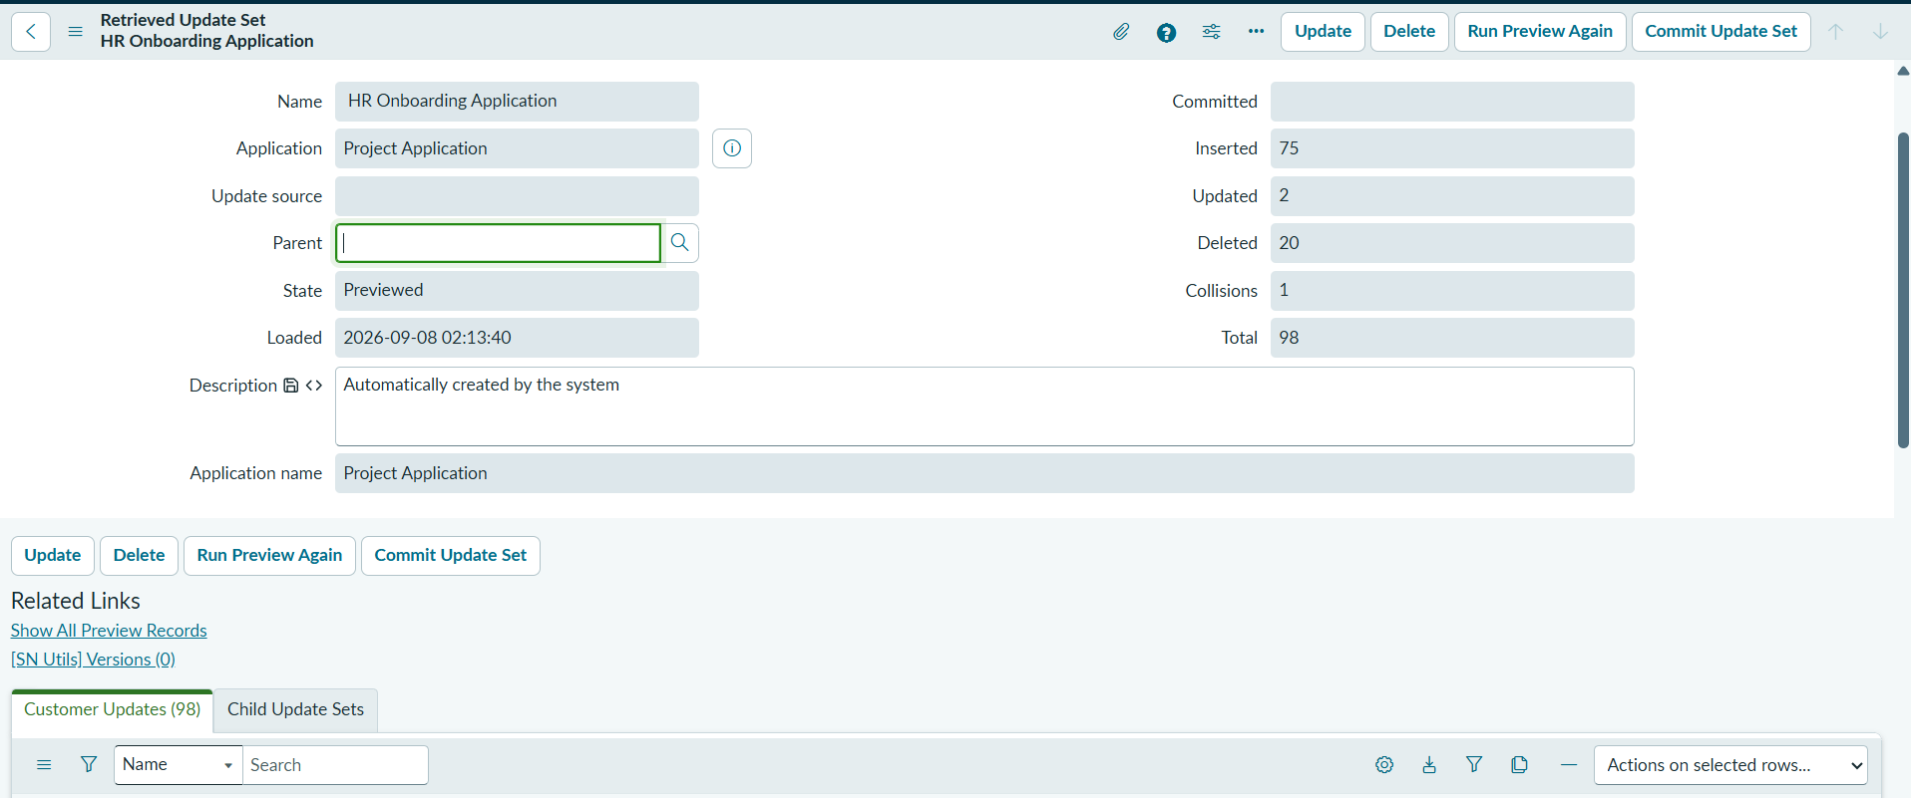

5. Commit / Export
After successful preview, commit the update set to the target instance. If the configuration is transferred through XML, export the completed update set and import it into the target instance, then validate the imported records.
Complete state, XML export and target-instance import.

6. Final Validation Checklist
Validation | Result
Request creation | ☐ Pass
Duplicate prevention | ☐ Pass
Manager approval | ☐ Pass
Approval notification | ☐ Pass
Rejection notification | ☐ Pass
IT notification | ☐ Pass
ACL access | ☐ Pass
Update Set Preview | ☐ Pass
Deployment | ☐ Pass

